Fabric8

A program package for evaluation of orientation data
and paleostress data,
for strain analysis,
and for analysis
of fold shapes


Paracelsusgasse 59
A-8010 Graz, Austria
e-mail: eckart.wallbrecher@uni-graz.at

1.1 Content of the Package

The program package FABRIC7 consists of the executable program

Fabric7.exe,

and the dll-programs
Further files are:
- LIZENZ.bin (contains the name of the licence owner, when the program was bought, or the word ‚Demo’, when the program is tested with a temporary licence.)
- DEUTSCH7.txt (contains the text of the German dialogues.)
- ENGLISH7.txt (contains the text of the English dialogues.)
- HILFDEUT.txt (contains the text of the German explanations of the speed button functions.)
- HELPENGL (contains the text of the English explanations of the speed button functions.)
- FABRIC7.ini (saves all settings of the last Fabric 7 session.)
- TestConfig.txt (Is used to check the file Fabric7.ini for correct spelling and completeness.)

FABRIC7.exe is the program for evaluation of orientation data. Usually the program run without errors, but this does not mean that errors may not arise under conditions which we didn not test. In this case we send a corrected version of the code. Suggestions for improvements are always welcome.

1.2 Hardware-Configuration
The programs run on PCs under Windows 9x, 2000, Windows NT, Windows XP, or Vista.

1.3 Improvements of Fabric6
The program Fabric6 has been completely reworked and converted to Windows. The algorithms and graphics are essentially the same.
Many new applications and new programs have been added. Existing programmes have been extended considerably.

2. Installation
The program can be obtained in two ways:
1) The program can be downloaded from the website ‚geolsoft.com’. The download is in compressed form and must be unzipped with a suitable program.
2) The program is delivered in compressed form on a CD-rom and must be saved in decompressed form in a directory. This is done with the windows installation assistant. Go to the CD-Rom drive and double click on the setup symbol, then follow the installation assistant. Restart the computer after installation.

3. Application
All parameters of Fabric7.ini (Colours, lines, Data-directory etc.) may be changed with a text editor, but it might be better to use the preset parameters and change them during run time. The file „Fabric7.ini“ contains the following lines:

Configuration File:
Grafic
Background Colour :,clAqua
Frame Colour :,$FFFFFFFF
Periphery Colour :,clWhite
Diagram Colour :,clWhite
Colour of Data Points :,clRed
Colour of Great Circles :,clRed
Data Symbol :,FilledTriangle
Line Style :,Solid
Colour of Rose Diagram :,clRed
2nd Diskette :,e
Paths:
C:\Geologische Software\Daten\
c:\Geologische Software\Grafik
Hemisphere :,LOWER
Password :,N
Language :,Deutsch
Statistics
Confidence [%] :,99
Colour of Eigenvectors :,clRed
Colour of Aperture :,clRed
C. of Cone of Confidence :,clGreen
Projection :,Lambert
Colour of Nets :,clBlue
Colour of Equator :,clRed
Background of Diagrams :,clWhite
Colour of Coordinates :,clBlue
1st Contour Line :,clBlack
2nd Contour Line :,$0000FF80
3rd Contour Line :,clBlue
4th Contour Line :,$008000FF
5th Contour Line :,clBlack
Colour of Upper Slip Lines :,clRed
Colour of Lower Slip Lines :,clBlue
Colour of Arrows :,clRed
Formfactor theoretical :,clBlue
1st Contour Line :,SOLID
2nd Contour Line :,SOLID
3rd Contour Line :,SOLID
4th Contour Line :,SOLID
5th Contour Line :,Solid
Distance between Contours :,MANUAL
1st Contour Line x 10 :,10
2nd Contour Line x 10 :,20
3rd Contour Line x 10 :,40
4th Contour Line x 10 :,60
5th Contour Line x 10 :,120
Counting Calotte x 10 :,20
Multiple of Random (CLODAT):, 3.0
Pooled Group Aperture :,clBlue
Pooled Group C. of Confid. :,clBlack
Paper Plot :,HPGL
Paper Size :,DinA4
Format :,Portrait
Colour of Periphery :,clWhite
Radius [mm] :,80
X-Coordinate of Centre [mm]:,100
Y-Coordinate of Centre [mm]:,80
Rose Diagram (Style) :,Star
Rose Diagram (Interval) :,20
Rose Diagram (Increment) :,4
Paleo-Stress Azimut Sigma1 :,120
Paleo-Stress Dip Sigma1 :,30
Paleo-Stress Azimut Sigma3 :,225
Paleo-Stress Dip Sigma3 :,25
Length of Coordinates [mm] :,200
X-Coordin. of Origine [mm] :,20
Y-Coordin. of Origine [mm] :,100
Distance of Circles Deg. :,2
Distance of Points Deg. :,2
Tilt Angle Deg. :,0
Colour of Background :,clWhite
Radius of bitmap [%] :,20
X-Coord. bitmap centre [%] :,30
Y-Coord. bitmap centre [%] :,30
Colour of shearbox objects :,clRED
Colour of sheared objects :,clBLUE
Colour of compression :,clRED
Colour of extension :,clBLACK
Symbol of compression :,FilledCircle
Symbol of extension :,FilledCircle
Colour of Polygons :,clRed
Maximum number of data :,1000
Calibration factor for plot:,1.4184
Screen dump calibration :,1
Smoothing factor :,6
Type of Diagram :,floating
Enlargement (Fry-method) :,1
Colour of ellipse (Fry) :,clBlue
Colour of points (Fry) :,clRed
Colour of area (Fry) :,clAqua
Colour of sigma :,$00400040
Colour of clicked point :,$00804000
Colour of Fourier points :,clRed
Show copyright :,NO
Colour of polygons :,clBlue
Colour of isogons :,clRed
Pen width (in pixel) :,2
1. contour line pen width :,1
2. contour line pen width :,1
3. contour line pen width :,1
4. contour line pen width :,1
5. contour line pen width :,1
Counting grid distance :,12
Colour of foto-lineations :,clWhite
Length of symbols (map) :,20
Percent (Rf/Phi) :,5
Colour of harmonic mean :,clRed
Colour of vector mean :,clBlue
Colour of chi-square back :,clSilver
Colour of chi-coordinates :,clBlue
Colour of chi-graph :,clRed
Brushstyle of ellipse (Fry):,transparent
Save Image Width (Fry-Plot):,1200
Save Image Width (d-Theta) :,1222
Save Image Width (Marker) :,1400
Save Image Width (Stereo) :,1420
Save Image Width (Fourier) :,1222
Save Image Width (Mohr) :,850
Save Image Width (TAlpha) :,700
Save Image Width (Shear) :,2200
Save Image Width (Panozzo) :,1000
Save Image Width (Isogonen):,1000
Save Image Width (Chi-sq.) :,1000
Colour of ellipse (Calcul.):,clBlue
Colour of area (Calculated):,clYellow
Brushstyle of ellipse (Cal):,transparent
Windows <= Xp or Vista :,Vista

4. The Program FABRIC7

When you start a FABRIC7 session you can choose the language (Fig. 1).

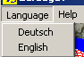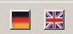
Fig. 1

On each form of all subprograms you can call a help function, look into the manual, or open the reference list (Abb. 2).

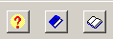
Fig. 2

When you run Fabric7 for the first time, it is necessary to click either on the option ‘Xp or older’ or ‘Vista in the menu ‘Windows Version’ according to the windows version your computer uses (Fig. 3).

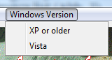
Fig. 3

This became necessary because with Vista Microsoft does not support the old winhelp-function any more, so an additional help program had to be written for users of Vista.

By clicking on the button „Start“, you open the next form (Fig.4). By scrolling and double click you choose the program, you want to work with.
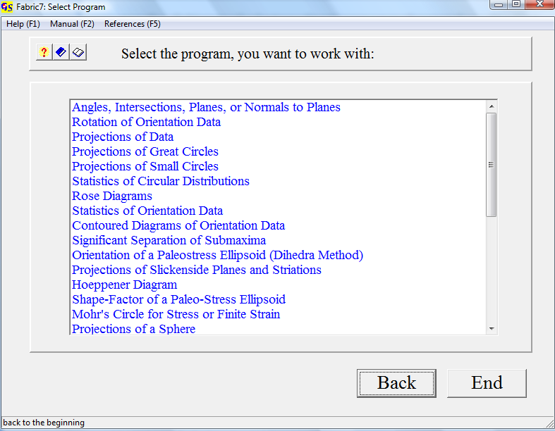
Fig. 4

Fabric7 contains the following programs:
1. CALCULATIONS
2. ROTATION
3. PLOT DATA
4. PLOT GREAT CIRCLES
5. PLOT SMALL CIRCLES
6. CIRCULAR MEASURES
7. ROSE DIAGRAMS
8. FABRIC STATISTICS
9. CONTOUR LINES
10. CLUSTERS OF ORIENTATION DATA
11. PALAEO STRESS
12. PLOT SLICKENSIDES
13. PLOT HOEPPENER-DIAGRAMS
14. SHAPE-FACTOR OF A PALAEO STRESS-ELLIPSOID
15. MOHR’S CIRCLE
16. PROJECTIONS
17. RECONSTRUCTION OF DATA
18. PLOT R%-G%-DIAGRAMM
19. WOODCOCK-DIAGRAMM
20. VOLLMER-DIAGRAMM
21. TEST OF SIGNIFICANCE
22. FOURIER-ANALYSIS OF FOLDS
23. T'ALPHA/ALPHA-PLOT OF FOLDS
24. ISOGONEN
25. SIMULATION OF SHEAR STRAIN
26. TALBOT-METHOD
27. FRY METHOD OF MEASURING STRAIN
28. PROJECTION METHOD OF MEASURING STRAIN
29. RF/Φ−METHOD OF MEASURING STRAIN
30. PLOT DATA INTO A MAP

1 to 10 are used for presentation and statistical evaluation of orientation data which must have the form "azimuth of dip/angle of dip", or "strike/dip dip direction", or data can be readings from a universal stage. The methods for treatment and statistical evaluation of these data are described in detail in WALLBRECHER (1986). For short information see the power point presentation in file “Theory”.
The method of palaeo-stress analysis (11) with compressional dihedra is described by ANGELIER & MECHLER (1977). The Hoeppener-Diagram (13) has been introduced by HOEPPENER (1955). The shape factor of a palaeo-stress ellipsoid (14) is described by WALLBRECHER et al. (1996).
The use of Mohr’s circle (15) is described by MEANS (1976).
The WOODCOCK-Diagram (19) was introduced by WOODCOCK (1977), and the VOLLMER-Diagram (20) by VOLLMER (1990).
The test of significance (21) is programmed after WOODCOCK & NAYLOR (1983).
The programs of these three groups are linked in each group i.e. you can jump from one program to another one in the group by mouse click.
The methods applied in the programs FOURIER (22) und T’ALPHA/ALPHA (23) are taken from RAMSAY & HUBER (1987).
The Talbot-Method (26) is described by Talbot (1970) und RAMSAY & HUBER (1987).
The Fry-Method (27) is explained in RAMSAY & HUBER (1987).
The "enhanced" Fry method was introduced by ERSLEV (1988).
The projection method (28) was developed 1984 by Panozzo for strain analysis.
The Rf/φ−Method (29) was developed by Lisle (1985) for strain analysis of primary elliptical markers.
The last program (30) enables you to draw a simple structural map from measured data and geographic, Gauss-Krueger-, or UTM-coordinates..
In all programs which require data input, manual input is possible. Data files are in ASCII format. This allows later corrections with a text editor.
Data input from one or more files or directly from an excel sheet is also possible.
Data lists and calculated parameters can also be printed or saved in a *.rtf-file. You can switch during run time between programs which use the same data format.

5. Graphic
The screen resolution should be set to 1024 X 768 pixels.
All screen graphics can be exported as bitmaps into text or graphic files.
*.BMP, *GIF, *.TIF, *.JPG, *.WMF, and *.EMF formats can be used.
Vector graphics can also be converted to *.PLT- or *.DXF-files for later treatment with graphic programs as Coral-Draw or Autocad. Direct plot on a colour printer is also possible.

